Title should be in bold, 16-point type and centered

Author name(s) [10-point type, centered, bolded]
Author(s) affiliation(s) and address(s) (8-point type, centered, italicized)
Corresponding author e-mail (8-point type, centered, italicized)

1. Formatting of main text and page layout
Your abstract should be a summary of your work and will be reproduced directly from the material you submitted for publishing in the Proceedings of the 9th International Workshop “Nanocarbon Photonics and Optoelectronics”.
The submission format is pdf. Since there is no typesetting or copy-editing of summaries, the use of this template is critical to provide a consistent appearance.
The length of the abstract is 1 page. Use A4 paper with 1 in. margins (2.54 cm) on all sides and 10-point Times New Roman font. The language of the abstracts is English. The first line of the first paragraph of a section or subsection should start flush left. The first line of subsequent paragraphs within the section or subsection should be indented 0.2 in. (0.62 cm).
2. Figures and tables
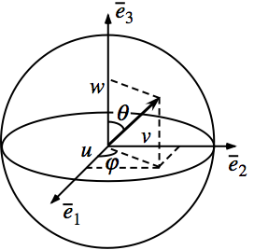
Figures and tables should be centered or placed side by side (depending on the figure size) and located inside paper margins. Text should not wrap around figures or tables; table captions (10-point font) should be centered above tables, and figure captions (8-point font) should be centered below figures (see Fig.1). Both should appear as close as possible to where they are mentioned in the main text.
Fig. 1. Poincare sphere
3. Equations
Equations should be centered, and equation numbers should only appear to the right of the last line of the equation, in parentheses.
(1)
For long equations, the equation number may appear on the next line.

3. Acknowledgement.
If you wish you may include an acknowledgment of grants support at the end of the main text.
4. References
References should appear at the end of the paper in the order in which they are referenced in the body of the abstract. The font should be 8 point, and the references should be aligned left.
Within the main text, references should be designated by a number in brackets [1], and they should be followed by a comma or period [2]. Two references cited at once should be included together [3,4], separated by a comma, while three or more consecutive references should be indicated by the bounding numbers and a dash [1–4].

[1] Yu. P. Svirko and N. I. Zheludev, Polarization of Light in Nonlinear Optics, (Wiley, Chichester, 1998)
[2] A. N. Obraztsov, G. M. Mikheev, Yu. P. Svirko, R. G. Zonov, A. P. Volkov, D. A. Lyashenko and K. Paivasaari, Diamond and Related Materials, 15, 842 (2006).

